ACS ALGORITHM/CHEST PAIN
Assess and care for the patient using the primary and secondary surveys.
***OBTAIN A 12 LEAD EKG***
If the patient is infarcting it is imperative that they be transported to a facility capable of percutaneous transluminal coronary intervention if within 90 minutes.
- Monitor and support ABCs (airway, breathing, and circulation).
- If the patient’s pulse oximetry is less than 94% administer oxygen at a level that increases the saturation to between 94 and 99%. If the patient has a history of COPD administer oxygen if their pulse ox falls below 90% on room air
- Establish IV access.
- If the patient did not receive aspirin from the EMS provider, give aspirin (160 to 325 mg).
- Administer nitroglycerin 0.4mg q 5 minutes, either sublingual, spray. Withhold Nitroglycerin on the patient who is experiencing Right Ventricular Infarction/ED meds/BP <90.
- Give the patient a narcotic pain reliever such as Fentanyl, Morphine or Dilaudid if pain is not relieved by nitroglycerin. Morphine (2-6) is the drug of choice for infarction, but should be used with caution in the unstable angina patient.
STEMI GOES TO CATH LAB (PCI)
STROKE ALGORITHM
Identify signs of a possible stroke.
- Facial Droop (have patient show teeth or smile)
- Arm Drift (patient closes eyes and extends both arms straight out, with palms up for 10 seconds)
- Abnormal Speech (have the patient say “you can’t teach an old dog new tricks”)
If any 1 of these 3 signs is abnormal, the probability of a stroke is 72%
Check blood glucose level
Prior to any treatment a Head CT must be performed. 20% of strokes are bleeds and fibrinolytics are contraindicated
EMS must transport to a facility capable of doing a CT and treating a stroke ( stroke center )

Stable/Unstable Tachycardia Algorithm
Does the patient have a pulse?Is the patient stable?
Look for altered mental status, ongoing chest pain, hypotension, or other signs of shock.
Remember: Rate-related symptoms are uncommon if heart rate is < 150 bpm.
Yes, the patient is stable. Take the following actions:
- Obtain a 12-lead ECG or rhythm strip.
- Start an IV.
- Vagal maneuvers
Is the QRS complex wide or narrow?
Patient | Treatment
The patient's QRS is narrow and rhythm is regular. | Try vagal maneuvers. Give adenosine 6 mg rapid IV push. If patient does not convert, give adenosine 12 mg rapid IV push.
The patient's rhythm is irregular. | Control patient's rate with diltiazem (Cardizem ) or beta-blockers. Use beta-blockers with caution for patients with pulmonary disease or congestive heart failure.
If the rhythm pattern is irregular narrow-complex tachycardia, it is probably atrial fibrillation, possible atrial flutter, or multi-focal atrial tachycardia.
Patient is in ventricular tachycardia or uncertain rhythm. | Adenosine 6 mg rapid IV push If no conversion, give adenosine 12 mg rapid IV push;. Amiodarone 150 mg IV over 10 min Prepare for elective synchronized cardioversion.
UNSTABLE TACHYCARDIA
1.Immediate cardioversion (synchronized ) 100/200/300/
2.Atrial fib- 120-200
3.Sedate when pt. condition permits

BRADYCARDIA
***OBTAIN 12 LEAD ***
Assess and manage the patient using the primary and secondary surveys:
- O2 SAT between 94-99%-hypoxia causes bradycardia
- Decide whether the patient has adequate or poor perfusion, since the treatment sequence is determined by the severity of the patient's clinical presentation.
  - If pt is stable.
    - Consider administering atropine 0.5 mg IV if IV access is available Repeat every 3 to 5 minutes up to 3mg or 6 doses.
    - Consider epinephrine or dopamine
      - Epinephrine 2 to 10 µg/min
      - Dopamine 2 to 10 µg/kg per minute
  - If pt is unstable,:
    - Prepare for transcutaneous pacing. Do not delay pacing. If no IV is present pacing can be first.
    - SECOND DEGREE TYPE 1- LONGER, LONGER UNTIL GONE
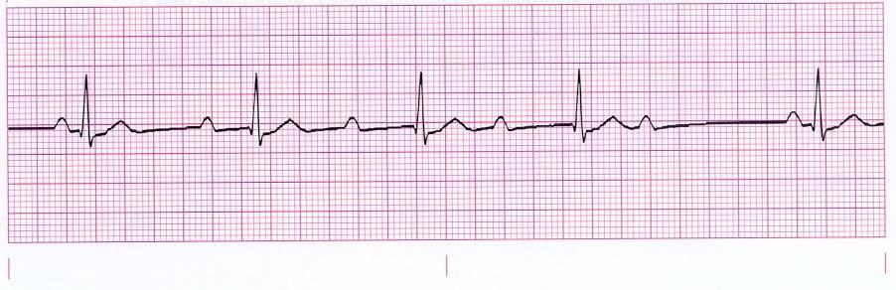
SECOND DEGREE TYPE 2-SAME PR
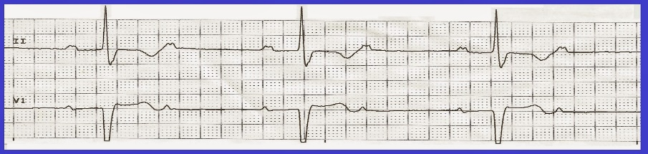
THIRD DEGREE- NO ASSOCIATION
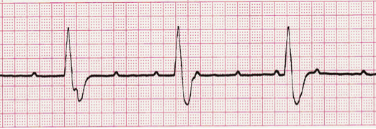
- Hypovolemia  - Hypoxia  - Hydrogen ion – acidosis  - Hyperkalemia / Hypokalemia  - Hypothermia  - Hypoglycemia  and other metabolic disorders | - Tablets (drug OD, accidents)  - Tamponade (cardiac)  - Tension pneumothorax  - Thrombosis, coronary (ACS)  - Thrombosis, pulmonary (embolism)  - Trauma

- Hypovolemia  - Hypoxia  - Hydrogen ion – acidosis  - Hyperkalemia / Hypokalemia  - Hypothermia  - Hypoglycemia  and other metabolic disorders | - Tablets (drug OD, accidents)  - Tamponade (cardiac)  - Tension pneumothorax  - Thrombosis, coronary (ACS)  - Thrombosis, pulmonary (embolism)  - Trauma

- Hypovolemia  - Hypoxia  - Hydrogen ion – acidosis  - Hyperkalemia / Hypokalemia  - Hypothermia  - Hypoglycemia  and other metabolic disorders | - Tablets (drug OD, accidents)  - Tamponade (cardiac)  - Tension pneumothorax  - Thrombosis, coronary (ACS)  - Thrombosis, pulmonary (embolism)  - Trauma

- Hypovolemia  - Hypoxia  - Hydrogen ion – acidosis  - Hyperkalemia / Hypokalemia  - Hypothermia  - Hypoglycemia  and other metabolic disorders | - Tablets (drug OD, accidents)  - Tamponade (cardiac)  - Tension pneumothorax  - Thrombosis, coronary (ACS)  - Thrombosis, pulmonary (embolism)  - Trauma
PEA/ASYSTOLE ALGORITHM
Patients with PEA have poor outcomes. Their best chance of returning to a perfusing rhythm is through the quick identification of an underlying reversible cause and correct treatment. As you use the algorithm to manage the PEA patient, remember to consider all the H's and T's, particularly hypovolemia, which is the most common cause of PEA. Also look for drug overdoses or poisonings.

Begin with the primary survey to assess the patient's condition:
- Pulseless Electrical Activity (PEA) occurs when you see a rhythm on the monitor that would normally be associated with a pulse, however the patient is pulseless.
- The rhythm can be anything, at any heart rate
- There is something preventing the heart from generating a pulse, such as Hypovolemia ,Tamponade or another H&T’s
- Re-assess the patient frequently for the return of pulses

Follow the ACLS Pulseless Arrest Algorithm
- Begin CPR as soon as pulselessness is recognized. Continue CPR at a rate of 100 to 120 per minute throughout the resuscitation without interuptions of more than 10 seconds to evaluate for pulses.
- Compressors should be switched every 2 minutes to ensure efficacy of compressions
- Waveform capnography should be utilized to monitor efficacy of compressions and (should generate at least 10MM/HG) and the return of pulses (will cause an increase in capnography to 40 or higher)Waveform capnography is the gold standard to verify endotracheal intubation ( >0)
- Obtain IV/IO access.Try ACF first -both sides then I/O
- Assess rhythm every 2 minutes Administer Epinephrine 1 mg IV/IO every 3-5 minutes
- Find and treat underlying causes. Rule out H&T’S
- Hypovolemia  - Hypoxia  - Hydrogen ion – acidosis  - Hyperkalemia / Hypokalemia  - Hypothermia  - Hypoglycemia  and other metabolic disorders | - Tablets (drug OD, accidents)  - Tamponade (cardiac)  - Tension pneumothorax  - Thrombosis, coronary (ACS)  - Thrombosis, pulmonary (embolism)  - Trauma

VFIB/PULSELESS V-TACH ALGORITHM
- Hypovolemia  - Hypoxia  - Hydrogen ion – acidosis  - Hyperkalemia / Hypokalemia  - Hypothermia  - Hypoglycemia  and other metabolic disorders | - Tablets (drug OD, accidents)  - Tamponade (cardiac)  - Tension pneumothorax  - Thrombosis, coronary (ACS)  - Thrombosis, pulmonary (embolism)  - Trauma
- Begin CPR as soon as pulselessness is recognized. Continue CPR at a rate of 100 to 120 per minute throughout the resuscitation without interruptions of more than 10 seconds to evaluate for pulses.
- Compressors should be switched every 2 minutes to ensure efficacy of compressions
- Assess rhythm if shockable defibrillate 200 j or manufacture’s recommendation
- Waveform capnography should be utilized to monitor efficacy of compressions and (should generate at least 10MM/HG) and the return of pulses (will cause an increase in capnography to 40 or higher)Waveform capnography is the gold standard to verify endotracheal intubation ( >0)
- Obtain IV/IO access.Try ACF first -both sides then I/O
- Administer Epinephrine 1 mg IV/IO during compressions followed by 20 cc flush
- Circulate Epi for 2 minutes while Ruling out H&T’S
- Assess rhythm if shockable defibrillate 200 j or manufacture’s recommendation
- Give Amio 300m mg IV/IO during compressions followed by 20 cc flush
- Circulate Amio for 2 minutes while Ruling out H&T’S
- Assess rhythm if shockable defibrillate 200 j or manufacture’s recommendation
- Repeat process- subsequent Amiodarone doses are 150 mg.
SHOCK-DRUG-SHOCK-DRUG-SHOCK-DRUG
2 MINUTES (5 CYCLES)BETWEEN DRUG AND SHOCK-RULE OUT H&T’S

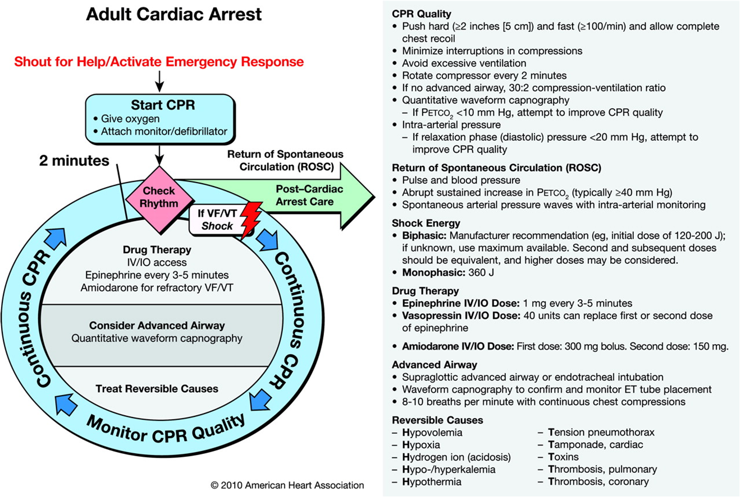

BLS SAVES LIVES
CAB NOT ABC-CIRCULATION IS PRIORITY2-2.4 INCHES /100-120 COMPRESSIONS PER MINUTE/ ALLOW COMPLETE CHEST RECOILCAPNOGRAPHY CAN HELP QUANTIFY EFFECTIVENESS OF CHEST COMPRESSIONS LESS THAN 10 IS POOR CHEST COMPRESSIONS
IMMEDIATELY START CPR AFTER DEFIBRILLATION

ROSC -RETURN OF SPONTANEOUS CIRCULATION

WHEN YOU SEE ORGANIZED NON SHOCKABLE RHYTHM ON THE MONITOR DURING RHYTHM CHECK THEN CHECK PULSE

- If pulse is present follow ROSC algorithm, if not it is PEA
- Use fluids and dopamine to obtain BP >90 systolic
- Everything is now concentrated on ventilation and oxygenation. If the pt is in respiratory arrest give 1 breath every 5-6 seconds. O2 between 94-99% Caponography between 35 -40 mm/hg
- Over next 24 hrs. obtain Target temperature therapy between 32-36 degrees C
- If ACS suspected do 12 lead and if STEMI send to PCI (cath lab)

Team Dynamics
Everyone must be proficient in their job or skill. If you cannot perform a skill as instructed due to lack of knowledge or if it is outside of you scope of practice inform team leader. Clarify any mistakes or possible medication errors. Repeat back instructions to avoid misunderstandings (Closed loop communications).

The American Heart Association strongly promotes knowledge and proficiency in BLS, ACLS, and PALS and has developed instructional materials for this purpose. Use of these materials in an educational course does not represent course sponsorship by the American Heart Association, and any fees charged for such a course do not represent income to the Association

This handout is not an official AHA document

